INVESTMENT PROJECT SUMMARY/PROFILE
Construction of factory for the production of detergents
in the territory of FEZ “Kulob”
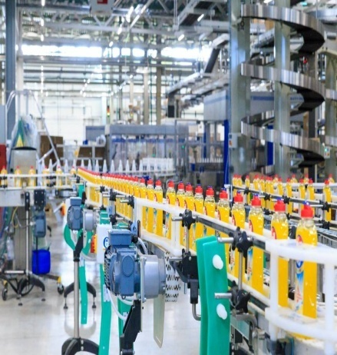 | 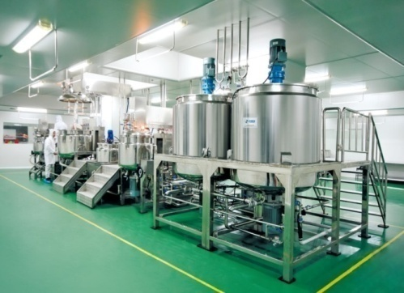 | 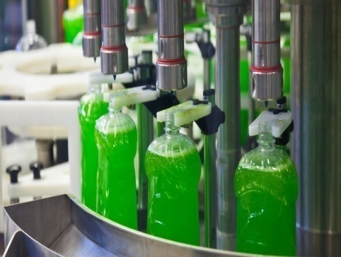
FEZ “Kulob”
Full name of the project | Construction of factory for the production of detergents in the territory of FEZ “Kulob”
Project initiator | Ministry of Economic Development and Trade of the RT, State Institution Administration of Free Economic Zone "Kulob"
Contact details | State Institution Administration of Free Economic Zone " Kulob", Republic of Tajikistan, Khatlon region, Kulob city, Ziraki rural community, Saryozi Miyona village  Tel: (+992) 8332222260  e-mail: fezkulob@gmail.com  Website: www.fezkulob.tj
Type of ownership | Private property
Sector | Light industry
Main idea of the project | Organization for the production of detergents. The purpose of the implementation is a description of the economic efficiency of creating the production of soap and detergents and the development of a phased plan for the organization of production and sales.  The category of synthetic detergents includes:  - universal detergents  - compositions for soaking laundry  - compositions for household needs  - special purpose equipment
Aim/result of project | Organizing of local production, providing the domestic market and increasing the export potential of the country.
Planned production capacity | 30 thousand pieces per year
Planned export volume, regions (if any) | 20% of manufactured products will be exported to countries near and far abroad. In countries such as Afghanistan, Uzbekistan and Kyrgyzstan.
Planned realization period (years) | 1-3 years
Stage of the project (business plan, project documentation, other) | A preliminary project proposal has been developed. It is necessary to develop a detailed business plan and conduct a feasibility study.
Project overall cost | 10 mln. US$
Including | Internal funds mln. US$
Including | Required investments 10 mln. US$
Profitability | 20%
Period for payback | 5 years
Type of investment | Direct investment
Investor participation form | Creation of a joint venture, the implementation of the project on the basis of an investment agreement.
Tax and custom benefits/privileges | - Entrepreneurial activity of FEZ subjects on the territory of FEZ "Kulob", regardless of ownership forms, is free from paying all kinds of taxes provided by the Tax Code of the Republic of Tajikistan except for the social tax and income tax.  - FEZ employees play the role of tax agents on withholding and paying to the budget social tax and income tax for FEZ subjects' employees, taxpayers of Tajikistan.  - Profits earned by foreign investors and foreign employees' wages received in foreign currency can be freely taken abroad and will not be taxed when taken abroad.  - Goods placed on FEZ "Kulob" territory are considered as being outside of customs territory of the Republic of Tajikistan, which allows for importing goods from abroad without paying import duty and VAT.  - Import of foreign and domestic goods, production and construction equipment into FEZ territory occurs without customs duties and taxes.  - When exporting goods from FEZ “Kulob” territory outside of the Republic of Tajikistan, taxes and customs duties are not collected with the exception of customs clearance fees; prohibitions and limitations of economic nature are not applied.  - When exporting goods from FEZ territory to the territory of Tajikistan customs duties and taxes are paid according to the legislation Republic of the Tajikistan.
Technical indicators
Location of project (or realization) | Republic of Tajikistan, Khatlon region, Kulob city, rural community of Ziraki, village of Saryozii Miyona, Free economic zone «Kulob»
Size of overall necessary production site (land) | More than 3 ha
Production area, ha | 2,8 ha
Planned number of jobs | 150z
Infrastructure/Communication
Power supply | A project for the construction of a substation on the territory of FEZ "Kulob" is being developed; Construction work will begin in the near future.
Water supply and sewerage | There are 3 wells on the territory of FEZ "Kulob", one of which is fully operational. In addition, it is planned to start in the near future construction work on drilling new wells, as well as the development of a new project to build a water supply and sanitation system on the territory of FEZ " Kulob"
Gas supply | There is none
Transport connection
Road | Connecting distance to international highway “Dushanbe- Kulob- Qalai -Khumb” 14 km to FEZ «Kulob»;  Regional highway Vose- Khovaling 7 km to FEZ «Kulob»;  220 km from the Dushanbe city to FEZ «Kulob»;
Airport | 1,5 km from Kulob international airport to FEZ «Kulob»;  220 km from Dushanbe international airport to FEZ «Kulob»;
Railway | 18 km from Railway station to FEZ «Kulob»

