INVESTMENT PROJECT SUMMARY/PROFILE
Construction of transport and logistics center in the territory of FEZ “Kulob”
 | 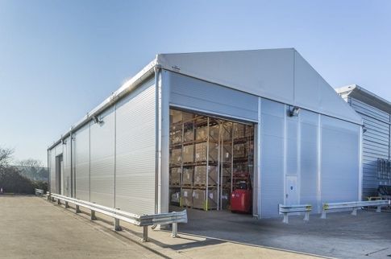 | 
FEZ “Kulob”
Full name of the project | Construction of transport and logistics center in the territory of FEZ “Kulob”
Project initiator | Ministry of Economic Development and Trade of the RT, State Institution Administration of Free Economic Zone "Kulob"
Contact details | State Institution Administration of Free Economic Zone " Kulob", Republic of Tajikistan, Khatlon region, Kulob city, Ziraki rural community, Saryozi Miyona village  Tel: (+992) 8332222260  e-mail: fezkulob@gmail.com  Website: www.fezkulob.tj
Type of ownership | Private property
Sector | Transport/Services
Main idea of the project | Creation of a multifunctional logistics center that meets the needs of modern market infrastructure.
Aim/result of project | Reliable zone for the transfer of goods locally and internationally;  Large and improved warehouses for storage of goods for import and export;  Warehouses for the storage of goods to international standards with their subsequent import and export;  Foreign trade activities  Development of transport and logistics services  Efficient logistics systems using modern technology and software  Establishment of effective land routes within Tajikistan and neighboring countries (central Asian countries, China, Pakistan, and Afghanistan.)  Supporting local and international trade;  Other activities that do not contradict the legislation of the Republic of Tajikistan
Services offered | Warehouse (responsible) storage:  Trade and logistics services (shipment of goods from one point to another),  Loading and offloading;  Packing  Additional services for the employees of the logistics center including hotel, gym, medical service, laundry and other services for the rest of the drivers and operators.
Planned realization period (years) | 3 years
Stage of the project (business plan, project documentation, other) | A preliminary project proposal has been developed. It is necessary to develop a detailed business plan and conduct a feasibility study.
Project overall cost | 7 mln US$
Including | Internal funds mln. US$
Including | Required investments 7 mln. US$
Profitability | 15%
Period for payback | 7 years
Type of investment | Direct investment
Investor participation form | Creation of a joint venture, the implementation of the project on the basis of an investment agreement.
Tax and custom benefits/privileges | - Entrepreneurial activity of FEZ subjects on the territory of FEZ "Kulob", regardless of ownership forms, is free from paying all kinds of taxes provided by the Tax Code of the Republic of Tajikistan except for the social tax and income tax.  - FEZ employees play the role of tax agents on withholding and paying to the budget social tax and income tax for FEZ subjects' employees, taxpayers of Tajikistan.  - Profits earned by foreign investors and foreign employees' wages received in foreign currency can be freely taken abroad and will not be taxed when taken abroad.  - Goods placed on FEZ "Kulob" territory are considered as being outside of customs territory of the Republic of Tajikistan, which allows for importing goods from abroad without paying import duty and VAT.  - Import of foreign and domestic goods, production and construction equipment into FEZ territory occurs without customs duties and taxes.  - When exporting goods from FEZ “Kulob” territory outside of the Republic of Tajikistan, taxes and customs duties are not collected with the exception of customs clearance fees; prohibitions and limitations of economic nature are not applied.  - When exporting goods from FEZ territory to the territory of Tajikistan customs duties and taxes are paid according to the legislation Republic of the Tajikistan
Technical indicators
Location of project (or realization) | Republic of Tajikistan, Khatlon region, Kulob city, rural community of Ziraki, village of Saryozii Miyona, Free economic zone «Kulob»
Size of overall necessary production site (land) | 7 ha
Planned number of jobs | 70
Infrastructure/Communication
Power supply | A project for the construction of a substation on the territory of FEZ "Kulob" is being developed; Construction work will begin in the near future.
Water supply and sewerage | There are 3 wells on the territory of FEZ " Kulob", one of which is fully operational. In addition, it is planned to start in the near future construction work on drilling new wells, as well as the development of a new project to build a water supply and sanitation system on the territory of FEZ " Kulob"
Gas supply | There is none.
Others | Availability of own experimental sites
Transport connection
Road | Connecting distance to international highway “Dushanbe- Kulob- Qalai -Khum” 14 km to FEZ «Kulob»;  Regional highway Vose- Khovaling 7 km to FEZ «Kulob»;  220 km from the Dushanbe city to FEZ «Kulob»;
Airport | 1,5 km from Kulob international airport to FEZ «Kulob»;  220 km from the Dushanbe international airport to FEZ «Kulob»;
Railway | 18 km from Railway station to FEZ «Kulob»

