INVESTMENT PROJECT SUMMARY/PROFILE
Construction of a plant for the production of halal meat products in the territory of FEZ “Kulob”
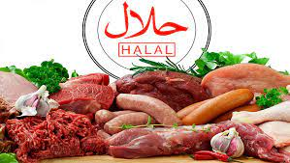 | 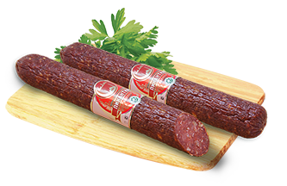 | 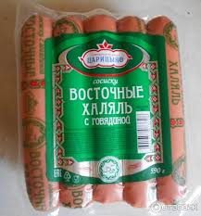
FEZ “Kulob”
Full name of the project | Construction of an enterprise for the production of meat products in the territory of FEZ “Kulob”
Contact details | State Institution Administration of Free Economic Zone " Kulob", Tajikistan, Khatlon region, Kulob city, Ziraki rural community, Saryozi Miyona village  Tel: (+992) 8332222260  e-mail: fezkulob@gmail.com  Website: www.fezkulob.tj
Type of ownership | Private property
Sector | Food industry
Main idea of the project | Organization of successfully developing enterprise, offering one of the widest ranges of sausages (boiled, smoked) and other meat delicacies, having consistently high quality and great taste.  The main advantage of its products in the meat processing market will be the commitment to produce not only tasty, but also healthy, clean product, beneficial to the body.  The main task of the company is to produce products that comply with the religious canons of Islam. Therefore, one of the principles of the company will be to produce only halal meat products.
Aim/result of project | Organizing local production, providing for the domestic market and increasing the export potential of the country.
Planned production capacity | 2 thousand tons a year
Planned export volume, regions (if any) | Produced products will be traded domestically and exported to the foreign countries of near and far such as Afghanistan, Uzbekistan, Kyrgyzstan.
Planned realization period (years) | 2 years
Stage of the project (business plan, project documentation, other) | A preliminary project proposal has been developed. It is necessary to develop a detailed business plan and conduct a feasibility study.
Project overall cost | 3 mln. US$
Including | Internal funds mln. US$
Including | Required investments 3 mln. US$
Profitability | 25%
Period for payback | 4 years
Type of investment | Direct investment
Investor participation form | 100% ownership by the investor of the company being created and/or the possibility of creating a joint venture, the allocation of the necessary land, the provision of tax and customs benefits.
Tax and custom benefits/privileges | Entrepreneurial activity of FEZ subjects on the territory of FEZ "Kulob", regardless of ownership forms, is free from paying all kinds of taxes provided by the Tax Code of the Republic of Tajikistan except for the social tax and income tax.  FEZ employees play the role of tax agents on withholding and paying to the budget social tax and income tax for FEZ subjects' employees, taxpayers of Tajikistan.  Profits earned by foreign investors and foreign employees' wages received in foreign currency can be freely taken abroad and will not be taxed when taken abroad.  Goods placed on FEZ "Kulob" territory are considered as being outside of customs territory of the Republic of Tajikistan, which allows for importing goods from abroad without paying import duty and VAT.  Import of foreign and domestic goods, production and construction equipment into FEZ territory occurs without customs duties and taxes.  When exporting goods from FEZ “Kulob” territory outside of the Republic of Tajikistan, taxes and customs duties are not collected with the exception of customs clearance fees; prohibitions and limitations of economic nature are not applied.  When exporting goods from FEZ territory to the territory of Tajikistan customs duties and taxes are paid according to the legislation Republic of the Tajikistan
Technical indicators
Location of project (or realization) | Republic of Tajikistan, Khatlon region, Kulob city, rural community of Ziraki, village of Saryozii Miyona, Free economic zone «Kulob»
Size of overall necessary production site (land) | More than 2 hectares
Production area, ha | Planned for 1,8 hectares
Planned number of jobs | More than 50 jobs
Infrastructure/Communication
Power supply | A project for the construction of a substation on the territory of FEZ "Kulob" is being developed; Construction work will begin in the near future.
Water supply and sewerage | There are 3 wells on the territory of FEZ " Kulob", one of which is fully operational. In addition, it is planned to start in the near future construction work on drilling new wells, as well as the development of a new project to build a water supply and sanitation system on the territory of FEZ " Kulob"
Gas supply | No
Others | Availability of own experimental sites
Transport connection
Road | Connecting distance to international highway “Dushanbe- Kulob- Qalai -Khumb” 14 km to FEZ «Kulob»;  Regional highway Vose- Khovaling 7 km to FEZ «Kulob»;  220 km from the Dushanbe city to FEZ «Kulob»;
Airport | 1,5 km from Kulob international airport to FEZ «Kulob»;  220 km from the Dushanbe international airport to FEZ «Kulob»;
Railway | 18 km from Railway station to FEZ «Kulob»

