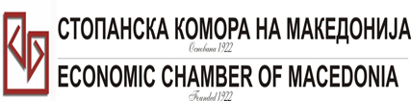
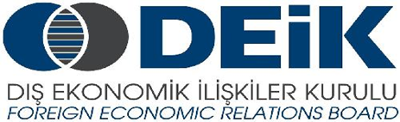

Бр: 14- 509/3 СКМ-ЗП-РУ-10/03

26.02.2015

Скопје

REGISTRATION FORM

МАКЕДОНСКО-ТУРСКA КОНВЕНЦИЈА
за заеднички настап на северно – африканскиот пазар,
23 март 2015
СТОПАНСКА КОМОРА НА МАКЕДОНИЈА

MACEDONIA – TURKEY – AFRICA
23.03.2015.

COMPANY INFORMATION
Company Name: | DARKOS DOOEL
Address: | Vera Ciriviri 18
Website: | www.darkos.com.mk
Year of Establishment | 1990
COMPANY REPRESENTATIVE INFORMATION
Name of the participant: | Kostadin Nikolovski
Position in the company:

ACTIVITY OF THE COMPANY
Brief information about the company | Production of gears, gearbox and spare parts for propulsion mechanisms
FIELD OF ACTIVITY:

Number of workers: | 25
Products/Servicess : | Gears, Gearbox, Spare parts for propulsion mechansisms
Expected cooperation from the Turkish partners at African market (please describe) | Subcontracting, Cooperation, Joint production
Total turnover in 2014(USD)
Total export figure for 2014(USD)
Exporting countries
Trademarks and certificates company have: | ISO 9001:2008

