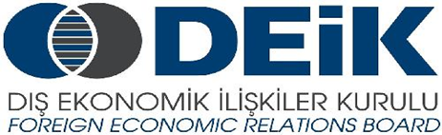
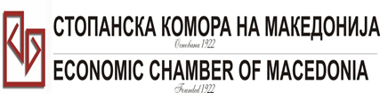

Бр: 14- 509/3 СКМ-ЗП-РУ-10/03

26.02.2015

Скопје

REGISTRATION FORM

МАКЕДОНСКО-ТУРСКA КОНВЕНЦИЈА
за заеднички настап на северно – африканскиот пазар,
23 март 2015
СТОПАНСКА КОМОРА НА МАКЕДОНИЈА

MACEDONIA – TURKEY – AFRICA
23.03.2015.

COMPANY INFORMATION
Company Name: | DPPU Vivaks Doo
Address: | bul. Treta Makedonska Brigada br.92
Website: | www.vivaks.com.mk
Year of Establishment | 1994
COMPANY REPRESENTATIVE INFORMATION
Name of the participant: | Risto Josifovski; Tanja Atanasovska
Position in the company: | Sales director; Marketing director

ACTIVITY OF THE COMPANY
Brief information about the company | Vivaks Company is a manufacturer of one of the best known brands in the region, the juices VIVA.  Vivaks is a privately owned company founded in 1994, as a family firm. It deals with the production of natural juices. In the last 10 years Viva is a market leader, with about 40% share of the market.
FIELD OF ACTIVITY: | Production and dıstrıbutıon of nectars and drınks.
Number of workers: | 54 workers
Products/Servicess : | - Fruit juices (Doypack 0,2L; Purepack1L);  - Fruit nectars (Doypack 0,2L; Purepack 1L; Purepack 2L);  - Fruit drinks (Doypack 0,2L; Purepack 1L; Purepack 2L; PET 0.5L, PET 1,5L);  - Syrups (PET 1L)  - Ice tea (PET 0.5L; PET 1,5L)
Expected cooperation from the Turkish partners at African market (please describe) | Presentation and sale of our products at African market.
Total turnover in 2014(USD)
Total export figure for 2014(USD)
Exporting countries | BiH; Kosovo; Albania, USA
Trademarks and certificates company have: | ILS; ISO 22000;

