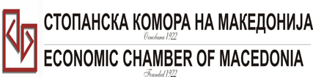
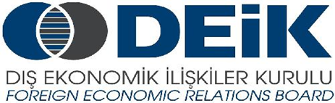

Бр: 14- 509/3 СКМ-ЗП-РУ-10/03

26.02.2015

Скопје

REGISTRATION FORM

МАКЕДОНСКО-ТУРСКA КОНВЕНЦИЈА
за заеднички настап на северно – африканскиот пазар,
23 март 2015
СТОПАНСКА КОМОРА НА МАКЕДОНИЈА

MACEDONIA – TURKEY – AFRICA
23.03.2015.

COMPANY INFORMATION
Company Name: | Kadino Industry Group DOOEL export-import
Address: | Str.10 No.:43 v.Kadino, Skopje, R.Macedonia
Website: | www.kadino.com.mk
Year of Establishment | 1992
COMPANY REPRESENTATIVE INFORMATION
Name of the participant: | Tome Gjorgjevski
Position in the company: | Prodaction manager

ACTIVITY OF THE COMPANY
Brief information about the company | KADINO Company is the first Mill-Baking  industry in the world which has  started up the idea of handcrafted production  of traditional filo products BUREK  Pie & Twirled BUREK and filo bites for retail and food service.  It is important to stress out the fact  that this company has also obtained the  Halal Certificate which is a guarantee for  the ingredients used necessary, for the  products, serving its purposes in the Muslim  world countries. Тhe most up-to-date accredited laboratory on the  Balkans has been integrated into the company  as to ensure the quality of its products,  and it carries out analyses on the  qualities of different types of wheat flours  with complete solutions for the Mill-Baking
FIELD OF ACTIVITY: | Millbaking industry
Number of workers: | 45
Products/Servicess : | BUREK Pie, Twirled BUREK and Filo bites
Expected cooperation from the Turkish partners at African market (please describe)
Total turnover in 2014(USD) | 6,5 miloin dollars
Total export figure for 2014(USD) | 286.000 dollars
Exporting countries | USA, Switzerland,Slovenia, Croatia, Germany
Trademarks and certificates company have: | The company has obtained the integrated  ISO 9001:2008, HACCP system.

Ве молиме за Вашиот интерес за учество на бизнис форумот, да го најавите најдоцна до 6.3.2015 година (петок).

