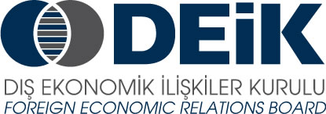 ANKET FORMU

FİRMA ADI: _______________________________________________
SEKTÖR: _________________________________________________
İLGİLİ KİŞİ: _______________________________________________
TEL: _______________________ FAKS: ________________________
EMAIL: ___________________________________________________

YUNANİSTAN’DAKİ MEVCUT FAALİYETLERİNİZ ____________________________________________________________________________________________________________________________________________________________________________________________________________________________________

YUNANİSTAN’DAKİ FAALİYETLERİNİZ SIRASINDA KARŞILAŞTIĞINIZ SORUNLAR VE ÇÖZÜM ÖNERİLERİNİZ
______________________________________________________________________________________________________________________________________________________________________________________________________________________________________________________________________________________________________________________________________________________________________________________________________________________________________________________________________________________________________________________________________________________________________________________________________________________________________________________________________________________________________________________________________________________________
TÜRKİYE İLE YUNANİSTAN ARASINDAKİ TİCARİ VE EKONOMİK İLİŞKİLERİN GELİŞTİRİLMESİ İÇİN ÖNERİLERİNİZ
________________________________________________________________________________________________________________________________________________________________________________________________________________________________________________________________________________________________________________________________________________________________________________________________
İLETİŞİM BİLGİLERİ : Sn.Neslihan Kilit
Tel: 0212 339 50 17, email: nkilit@deik.org.tr)

