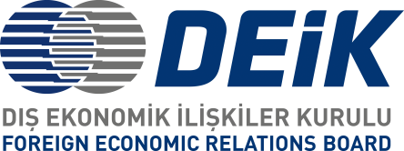

**BUSINESS AND INVESTMENT OPPORTUNITIES IN AFGHANISTAN**

**December 5th, 2019 – Istanbul**

**Venue: River Plaza**

**Draft Programme**

09:30 – 10:00 Registration

10:00 – 10:45 Opening speeches

* Mr. Süleyman Ciliv, Chairman of Turkey-Afghanistan Business Council
* Mr. Alham Omar Hotaki, CEO of NPA
* H.E. Dr. Mohammad Humayon Qayoumi, Minister of Finance of Islamic Republic of Afghanistan

10:45 – 12:00 Presentations

12:00 – 12:30 Q / A

12:00 – 14:00 Break

14:00 – 16:30 B2G Meetings