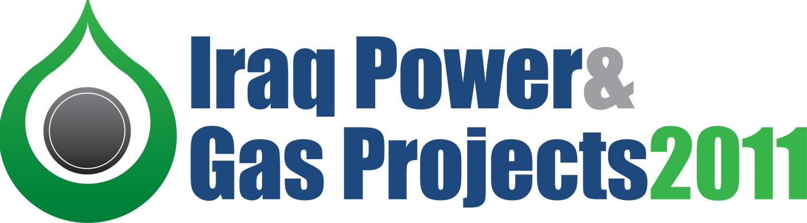

A comprehensive update on Iraq’s power projects masterplan, fuel allocation strategies and upcoming investment opportunities

Conference days: 13-14 June 2011
1 day Masterclass: 15 June 2011

Venue: Conrad Hotel, Istanbul, Turkey

1. Online at www.meed.com/events/iraq
Ways to register
2. Telephone MEED: +971 (0)4 390 0669
3. Email: events@meed.com
Confirmed speakers

- Ministry of Electricity, Iraq
- Salar Ameen, Vice Chairman, National Investment Commission (NIC)
- Ginger Cruz, Deputy Inspector General, Special Inspector General for Iraq Reconstruction
- Luay al-Khatteeb, Founder & Executive Director, Iraq Energy Institute
- Abdul Qader Ahmed, Power Projects Manager, Mass Global Investment Co.
- Jeff Larkin, Country Manager Iraq, Parsons Brinckerhoff
- Senior Representative, ABB
- Marina Hashim, Country President Jordan, Iraq Syria and Lebanon, Alstom
- Brigadier James Ellery CBE, Director, AEGIS
- Salem Chalabi, Legal Director, DLA Piper
- Erik Becker, Investment Officer, International Finance Corporation (IFC)
- Richard Kupisz, Associate Director, Head of PSP and Funds, IPA Energy + Water Economics
- Thomas Donovan, Lawyer, Iraq Law Alliance
- David Lockhart, Legal Consultant to the Iraq Law Alliance
- Ed James, Head of MEED Insight
- Jason Zhengrong Lu, Senior Underwriter, MIGA (Multilateral Investment Guarantee Agency)
- Sarab K. Hassan, Partner, Nuri Yaba Law Office
- Lawrence Peter, Director, Private Security Company Association of Iraq
- Amir Anvarie, Vice President, Sunir – Iran Power & Water Industries
- Ravi Suri, Head of Project Finance & Export, Standard Chartered Bank
- Iraq Country Chair, Shell
- Senior Representative, Siemens
- Paul Saville, Technical Director, Stellar Group
- Zaid A. Mahdi, Vice President – Business Development, Trade Bank of Iraq

Agenda

Conference day one, Monday 13 June 2011

08:30 Registration and coffee

09:15 Chairman’s welcome and opening remarks
Edmund O’Sullivan, Chairman, MEED Events

09:20 Keynote Interview
Insights into Iraq’s Electricity Policy
Ministry of Electricity, Iraq

10:00 The Iraq Power Masterplan
Iraq’s USS$27bn power generation and distribution masterplan update and the role of private sector
- Overview of the Ministry Of Electricity’s vision for power generation, transmission and distribution
- Update on Iraq’s load forecast and the latest strategy for its fuels mix
- Update on the short-term plan of action: 2011-2015
- Facts, figures, forecasts for the long-term: 2016-2030
- Actual expansion and distribution expectations outlined
Jeff Larkin, Country Manager Iraq, Parsons Brinckerhoff

10:30 Keynote presentation
Investment opportunities for power and energy developments in Iraq: Understanding the role of NIC
- Update on Iraq’s current investment environment
- Growth figures for Iraq’s energy sector with insights into upcoming investment opportunities
- Working with the NIC on successful mega projects
Salar Ameen, Vice Chairman, National Investment Commission (NIC)

11:00 Networking break

11:30 Legal review of Iraq’s Investment Laws as they apply to developing and financing infrastructure
David Lockhart, Legal Consultant to the Iraq Law Alliance

12:00 Future of private sector participation in developing Iraq’s power sector
- Outlining Iraq’s current electricity privatisation strategy for private sector participation (PSP)
- Understanding the rationale behind Iraq’s electricity PSP strategy - Iraq’s demand outlook and immediate requirements
- Update on the latest rules and regulations governing Iraq’s IPP model including the Iraqi grid code
- Review of current strategies to attract foreign investors including reforms of electricity tariffs
- Forecasting the long-term outlook for electricity privatisation – will IPP’s in Iraq really work?
Richard Kupisz, Associate Director, IPA Energy & Water Economics

12:30 Capitalising on Iraq’s natural resources to overcome the feedstock challenge
- Update on the current feedstock situation in Iraq
- Generation plan and fuel mix strategy – insights into Iraq’s plans to reduce liquid fuels reliance
- Capitalising on the benefits of utilising Iraq’s gas resources for domestic power generation
- Short-term strategy and long-term expectations for overcoming Iraq’s fuel concerns
Luay Al Khateeb, Founder & Executive Director, Iraq Energy Institute

13:00 Lunch and networking

14:30 Case study: Developments and achievements at Sadr City Power Plant
- Review of project from the contractors perspective
- Project update and forecasts
- The future developments at Sadr City Power Plant
Amir Anvari, Vice President, Sunir Company – Iran Power & Water Industries

15:00 Security, uncertainty and instability – protecting your people and investment
- Understanding your risk exposure and managing the security of mega projects
- Advice for how to effectively protect your plants and people (without breaking the bank)
- Understanding the role of the military to support movements
- Involving the community
Lawrence Peter, Director, Private Security Company Association of Iraq
Brigadier James Ellery CBE, Director, AEGIS

15:30 Networking break

16:00 Exploring practical financing options for mega power project opportunities in Iraq
- Overview of the realities of conventional project financing strategies in Iraq
- Is structured finance a practical option for Iraq?
- Is there a role for local and regional financial institutions in financing Iraq mega projects?
- Update on the increasing role of ECA’s and advice on how to make energy projects attractive to them
Erik Becker, Investment Officer, International Finance Corporation (IFC)
Ravi Suri, Head of Project Finance & Export, Standard Chartered Bank
Zaid A. Mahdi, Vice President – Business Development, Trade Bank of Iraq

16:30 Utilising political risk insurance to secure equity and debt financing
Jason Zhengrong Lu, Senior Underwriter, MIGA

17:00 Close of summit day one

17:15 Evening drinks reception

Join your colleagues and peers at the informal evening drinks reception for the opportunity to
discuss the issues surrounding operations in Iraq in the relaxed setting of the Hilton Conrad
Hotel.

Conference day two, Tuesday 14 June 2011

08:00 Power & Water breakfast

Analysis of current trends in regional power sector and future forecasts

Before we begin conference day two, enjoy breakfast and networking at the exclusive VIP breakfast meeting. This is an invaluable opportunity for conference participants, invited guests and government officials to connect and openly exchange ideas about the region’s power and energy project markets.
MEED will present facts, figures and forecasts on the region’s power projects developments, including Iraq.

Hosted by:
Ed James, Head of MEED Insight Spaces are strictly limited and attendance is confirmed on a ‘first-come, first-served’ basis

09:45 Chairman’s welcome and opening remarks

10:00 Kurdistan power case study: How did Northern Iraq achieve constant power for the people
- Update on successes to-date and the strategies that realised Kurdistan’s power requirements
- Ongoing infrastructure projects overview
- Operations and maintenance as the key to achieving sustainable power supply
- Training and technology transfer strategies for the sustainable future
Abdul Qader Ahmed, Power Projects Manager, Mass Global Investment Co.

10:45 Topic TBC
Senior Representative, ABB

11:30 Networking break

12:00 Iraq’s key fuel supply strategy; Update on the gas flaring projects and developing sufficient pipelines
- Update on the gas gathering, treatment and utilisation projects – timelines and expectations
- Analysis of possible future export routes and pipelines and the potential effect this will have on the region
- Managing future expansion projects to capitalise further on Iraq’s natural gas reserves
Iraq Country Chair, Shell

12:30 Case Study: Addressing immediate power needs - Rehabilitating power plants
- An insight into the project from the pre-mobilisation phase to the execution phase.
- The challenges of working in Iraq
- Identifying the key factors for running a successful project
Marina Hashim, Country President Jordan, Iraq Syria and Lebanon, Alstom

13:00 Developing Iraq’s legal framework and an update on the establishment of the Regulatory Office to develop commercial operations
- Current overview of Iraq’s regulatory framework for energy projects
- Role and responsibilities of the Regulatory Office
- Understanding how regulation in Iraq will support private sector development
- How to stay updated with the latest legislation amendments and regulations
Thomas Donovan, Lawyer, Iraq Law Alliance
Sabar J. Hassan, Partner, Nuri Yaba Law Office

13:30 Lunch and networking

14:30 Advances in Turbine Inlet Air Chilling (TIAC) systems for electrical power enhancement in hot climates
Paul Saville, Technical Director, Stellar Group

15:00 Update on Iraq’s significant turbine installation programme
- Status report on the 10,000MW turbine installation project
- Overview of the upcoming opportunities for EPC contractors
- The role the installation programme will play in increasing power capacity in Iraq to 27,000MW
- Where do the dangers lie?

15:30 Rebuilding and securing network links to ensure efficient distribution
- Overview of immediate transmission requirements
- Long-term distribution plan in review
- Real advice on how to protect against terrorism and looting
- Using government agencies and private companies to protect your investment

16:00 The Meed summation
Edmund O’Sullivan, Chairman, MEED Events

16:30 Close of conference and final thanks

Post-Summit Masterclass, Wednesday 15 June 2011

Implementing successful power projects in Iraq:
Practical legal, financial, insurance and security advice for setting up and protecting power projects in Iraq

10:00 – 15:00
Hosted by: Thomas Donovan, Lawyer, Iraq Law Alliance

Private Sector Participation (PSP) is continuing to develop at a rapid pace in the Iraq’s power & gas industries as the need to develop long-term relationships with local partners is essential for projects to be realised and succeed.

It is essential for you to be up-to-date with the latest regional PSP structures, compliance, local rules and practices in the emerging market of Iraq if one intends to be involved with the future of the power & gas industry. Update your knowledge of legal requirements and contracting strategies designed to protect your business and encourage growth at this essential masterclass.

Gain invaluable insights and advice from on the ground practitioners and develop key strategies in confronting the challenges of establishing power projects in Iraq to ensure you avoid common and easily avoided pitfalls.

The workshop will address key issues including:
- Winning the bid – what are the clients looking for?
- Acquiring the financing - developing financing strategies and available options specific to the unique marketplace which is Iraq
- Legalities – Establishing a corporate entity and separate corporate vehicles available to foreign investors; and process and timeline of incorporation.
- Compliance - Taxes, costing and auditing – understanding the tax system in Iraq
- Insurance - Insurance requirements and advice
- Protection - Protecting your investment and people; overcoming the security challenge in operating a constantly changing environment
Sponsorship opportunities

Bronze Sponsors:
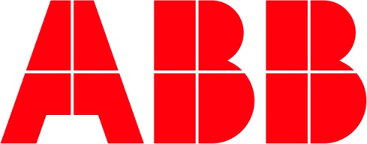
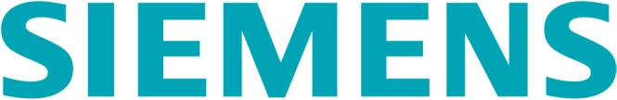

Exhibitors:

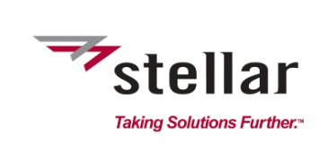

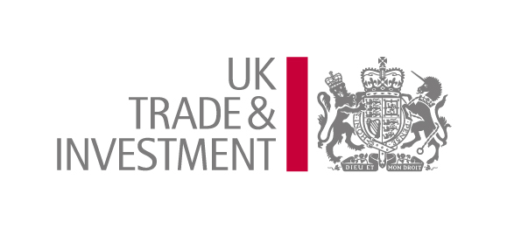
Event Partners:

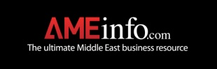
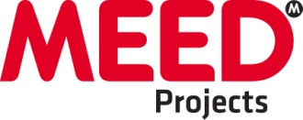

10 Things you will achieve by sponsoring the Iraq Power & Gas Projects conference:

- Access the most prominent industry representatives – expand your network with key Ministry officials
- Establish new business contacts – schedule follow up meetings
- Promote your company – make yourself stand out in a competitive market
- Engage in debates during the proceeding – position yourself as a thought leader
- Network with your peers – engage with your clients and suppliers
- Strengthen your existing relationships – open doors for new deals
- Raise your brand profile – achieve recognition in new markets
- Learn what is new in the market – incorporate this in your business strategy
- Share your thoughts on the industry challenges – contribute to industry sustainability
- Enjoy the networking breaks and social functions – cement friendships

Iraq Power & Gas Projects offers a superb and cost-effective platform for you to promote your brand, meet new clients and align yourselves with the key players in Iraq’s power and energy industry.

If you are serious about entering or expanding your business in the region, please contact Nish Liyanage on +971 (0)50 5581523, or email sponsorship@meed-dubai.com to arrange a convenient meeting time.
WAYS TO REGISTER:

1) Online at www.meed.com/events/iraq

2) Via telephone: +971 (0)4 390 0049

3) Email MEED: events@meed.com
Registration

Delegate Fees:

 | 2 day Conference + Masterclass | 2 day Conference only | Masterclass only
Payment before 21 March 2011 | US$3,400 | US$2,600 | US$1,500
Payment before 18 April 2011 | US$3,700 | US$2,750` | US$1,500
Normal rate | US$3,900 | US$2,850 | US$1,500
Onsite rate | US$4,250 | US$3,100 | US$1,750

Terms and conditions online at www.meed.com/ievents/iraq

