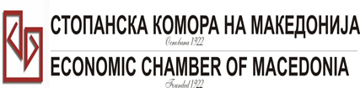
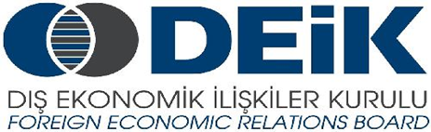

Бр: 14- 509/3 СКМ-ЗП-РУ-10/03

26.02.2015

Скопје

REGISTRATION FORM

МАКЕДОНСКО-ТУРСКA КОНВЕНЦИЈА
за заеднички настап на северно – африканскиот пазар,
23 март 2015
СТОПАНСКА КОМОРА НА МАКЕДОНИЈА

MACEDONIA – TURKEY – AFRICA
23.03.2015.

COMPANY INFORMATION
Company Name: | “Pleasure”
Address: | Str. Joakim Osogovski bb, Kriva Palanka Macedonia
Website: | www.pleasure.mk
Year of Establishment | 2007
COMPANY REPRESENTATIVE INFORMATION
Name of the participant: | Marija Mihajlova
Position in the company: | General Manager

ACTIVITY OF THE COMPANY
Brief information about the company | “Pleasure” is one of the fast growing Macedonian factories in the segment.  Our company is estaplished in 2007 and produces wafers and wafers products and deserts for domestic and foreign market.
FIELD OF ACTIVITY: | Our company produces wafers and wafers products and deserts.
Number of workers: | 58
Products/Servicess : | With quality product portfolio, excellent design and best quality of our products, we try to prove every day that “Pleasure” is a company focused on the consumers best quality and market needs
Expected cooperation from the Turkish partners at African market (please describe) | We expect to establish relation and good cooperation with potential exporting partners in the African market  We believe that our products have great export potential for this market
Total turnover in 2014(USD)
Total export figure for 2014(USD)
Exporting countries | Albania, Serbia, Montenegro, Kosovo, Austria, Bosnia and Herzegovina, Libya, Cyprus, Palestine
Trademarks and certificates company have: | “Pleasure”, “Sweet Pleasure”, “Kapri”  “HALAL” and “HACCP”.

