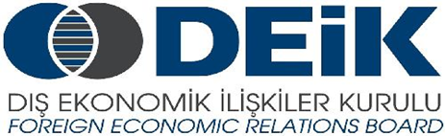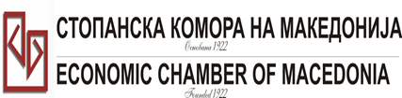

Бр: 14- 509/3 СКМ-ЗП-РУ-10/03

26.02.2015

Скопје

**REGISTRATION FORM**

**МАКЕДОНСКО-ТУРСКA КОНВЕНЦИЈА**

**за заеднички настап на северно – африканскиот пазар,**

**23 март 2015**

**СТОПАНСКА КОМОРА НА МАКЕДОНИЈА**

**MACEDONIA – TURKEY – AFRICA**

**23.03.2015.**

|  |  |
| --- | --- |
| **COMPANY INFORMATION** | |
| **Company Name:** | **P.I. VITAMINKA A.D.** |
| **Address:** | **Lece Koteski, 23; 7500 Prilep** |
| **Website:** | **www.vitaminka.com.mk/en** |
| **Year of Establishment** | **1956** |
| **COMPANY REPRESENTATIVE INFORMATION** |  |
| **Name of the participant:** | **Aleksandar Gjuroski** |
| **Position in the company:** | **Regional Export manager** |

|  |  |
| --- | --- |
| **ACTIVITY OF THE COMPANY** | |
| **Brief information about the company** | **VITAMINKA has been developing since 1956, and has thus acquired an extensive expertise in food production, becoming modern equipped leading manufacturing company in the food industry in the country and one of the biggest food producers in South-East Europe.**  **According to specific needs, our customers can choose between different flavors and performances. Our product range consists of nearly 400 types own branded and private label products within following categories: snacks (flips, chips-pellets), chocolates, chocolate coated products, cream spreads, ketchup, mayonnaise, soups, spices, instant vitamin's products, teas, biscuits, cookies, breakfast cereals etc.**  **We export to more than 30 countries, including Europe, USA, Canada, Australia and Asia.**  **Among the biggest retail chains that we are serving cooperatively, by honoring our multi-year agreements are the following: Rewe (Billa); Kaufland; Metro C&C; Spar; Delhaize; Coop; Auchan; Lidl.**  **ISO 9001:2008, HACCP, and IFS implemented standards ensure the high quality of our products. We are also in process of implementation of HALAL standards, which we will complete by June, 2015.**  **We regularly attend to some of the world biggest food fairs (ISM and ANUGA in Germany, SIAL in Paris, GULFFOOD in Dubai, FANCY FOOD in USA, WORLDFOOD in Moscow etc).** |
| **FIELD OF ACTIVITY:** | **Food manufacturing industry (confectionery industry)** |
| **Number of workers:** | **580** |
| **Products/Servicess :** | **Snacks (flips, chips-pellets), chocolates, chocolate coated products, cream spreads, ketchup, mayonnaise, soups, spices, instant vitamin's products, teas, biscuits, cookies, breakfast cereals etc.** |
| **Expected cooperation from the Turkish partners at African market (please describe)** | **We encourage establishing cooperation with food importers, food distributors, trade companies, retail chains etc.** |
| **Total turnover in 2014(USD)** | **29,620,000.00** |
| **Total export figure for 2014(USD)** | **12,400,000.00** |
| **Exporting countries** | **Almost all EU countries, Serbia, Bosnia, Albania, Turkey, Swiss, USA, Canada, Russia, Australia, Saudi Arabia, Iraq, Dubai, Peru** |
| **Trademarks and certificates company have:** | **ISO, HACCP, IFS (HALAL and KOSHER in progress)** |

Ве молиме за Вашиот интерес за учество на бизнис форумот, да го најавите **најдоцна до 6.3.2015 година (петок)*.***