Member of the Policy Board Ms. Sayuri Shirai
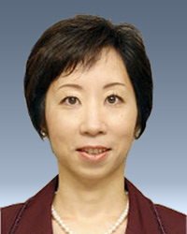
Date of Birth | January 2, 1963
Education | 1987, B.A. in Sociology, Keio University  1989, M.A. in Economics, Keio University  1993, Ph.D. in Economics, Columbia University
Date of appointment | Apr. 1, 2011

Record
Sep. 1993 | Economist, International Monetary Fund
Sep. 1998 | Associate Professor, Keio University
Apr. 2006 | Professor, Keio University
Apr. 2011 | Present position

