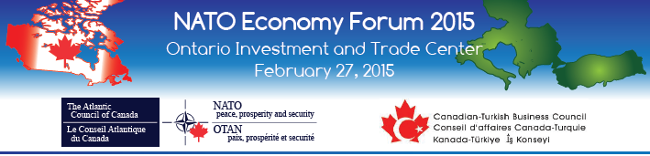

**NATO ECONOMY FORUM: TRADE AND INVESTMENT OPPORTUNITIES BETWEEN CANADA AND CENTRAL/SOUTH EASTERN EUROPE**

**International Delegate Profile**

**February 27, 2015**

**Please fill out this form and send it to the NATO Council of Canada by email to** [**events@natocouncil.ca**](mailto:events@natocouncil.ca) **or by fax to (416) 979-0825**

|  |
| --- |
| **Company Name:**  **Participant’s Name (incl. title):**  **Address:**  **City:**  **State:**  **Country:**  **Telephone:**  **E-mail:** |

* **Overview of your company**





* **Describe your Products and/or Services**

* **You would like to meet Canadian companies that provide the following products, services or technologies**





* **Your specific goals and expectations for the NATO Economy Forum**

