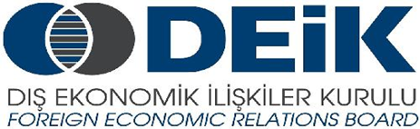
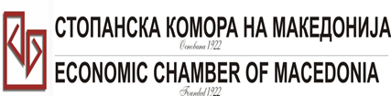

Бр: 14- 509/3 СКМ-ЗП-РУ-10/03

26.02.2015

Скопје

REGISTRATION FORM

МАКЕДОНСКО-ТУРСКA КОНВЕНЦИЈА
за заеднички настап на северно – африканскиот пазар,
23 март 2015
СТОПАНСКА КОМОРА НА МАКЕДОНИЈА

MACEDONIA – TURKEY – AFRICA
23.03.2015.

COMPANY INFORMATION
Company Name: | PUCKO PETROL DOOEL
Address: | Str. Plasnica - Skopje
Website:
Year of Establishment | 28.01.1999
COMPANY REPRESENTATIVE INFORMATION
Name of the participant: | - Asmir Jahoski - owner  Bozanka Grozdanova - CEO
Position in the company:
Languages spoken:

ACTIVITY OF THE COMPANY
Brief information about the company | For more tahn 20 years our retail department provides customer fuel with hieghest quality, excellent service and satisfy all the customer requirements.
FIELD OF ACTIVITY: | Wholesale of solid liquid and gaseous fuels.
Number of workers: | 130 employees
Products/Servicess : | Sale of petroleum and petroleum products
Expected cooperation from the Turkish partners at African market (please describe)
Total turnover in 2014(USD) | 31.092.883 USD
Total export figure for 2014(USD)
Exporting countries
Trademarks and certificates company have: | ISO 9001; ISO 14001; OKTA

Ве молиме за Вашиот интерес за учество на бизнис форумот, да го најавите најдоцна до 6.3.2015 година (петок).

