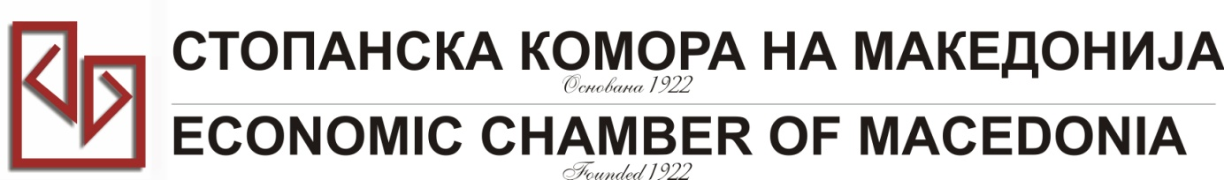

**MACEDONIA – TURKEY – AFRICA**

|  |  |
| --- | --- |
| **COMPANY INFORMATION** | |
| **Company Name:** | **MZTKOMERC NOVA Ltd** |
| **Address:** | **Bul. Treta Makedonska Brigada 48** |
| **Website:** | **www.mztkomercnova.com.mk** |
| **Year of Establishment** | **1982** |
| **COMPANY REPRESENTATIVE INFORMATION** |  |
| **Name of the participant:** | **Ljupco Velickovski** |
| **Position in the company:** | **Owner & CEO** |

|  |  |
| --- | --- |
| **ACTIVITY OF THE COMPANY** | |
| **Brief information about the company** | **Import of Raw Materials for the Factories in the group MZT - Skopje (Metalski Zavod TITO- Skopje)**  **Export of Products made in the Factories of the group MZT-Skopje (Metalski Zavod TITO - Skopje)** |
| **FIELD OF ACTIVITY:** | **Metalwork's Industry**  **Metallurgical Industry** |
| **Number of workers:** | **3** |
| **Products/Servicess :** | **International Export and Import of goods for/from metalwork's and metallurgical industry** |
| **Expected cooperation from the Turkish partners at African market (please describe it with details))** | **- Buying Ductile Iron Pipes for water Pipelines**  **- Selling Ductile Iron Fittings for water Pipelines (Fittings for D.I. pipes, for PE and PE-HD pipes, for PVC Pipes)**  **- Selling all types of Pumps (for water, oil, chemicals)**  **- Selling Hydro mechanical Equipment for open and closed channels for irrigation**  **- Selling Equipment for testing complete Brake Equipment on all types of Railway coaches in the specialized workshops or directly in the field (open railroad)**  **- Selling Steel Shots for Sand Blasting of Castings or Steel constructions - before painting**  **- Selling Safes and other Bureau technical Equipment** |
| **Total turnover in 2013(USD)** | **over 1.000.000 USD** |
| **Total export figure for 2013(USD)** | **1.000.000 USD** |
| **Exporting countries** | **Netherlands, Austria, Italy, Germany, Greece, France, Serbia, Croatia, Slovenia** |
| **Total import figure for 2013(USD):** | **100.000 USD** |
| **Importing countries:** | **Italy, Austria, Germany, Serbia** |
| **Trademarks and certificates company have:** | **ISO 9001: 2008; SME Excellent** |