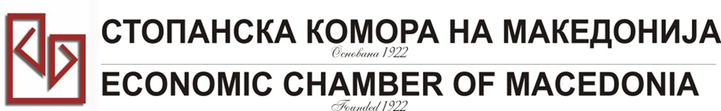
ДИРЕКЦИЈА ЗА РЕГИОНАЛНИ КОМОРИ И МЕЃУНАРОДНА СОРАБОТКА СКМ-ЗП-РУ-10/04
Бр: 14- 509/3
26.02.2015
Скопје
LIST OF PARTICIPANTS

“Македонски и турски бизниси заедно на африканскиот пазар -– предизвик или можност”
23 март 2015 година
Стопанска комора на Македонија

 | Фирма/Company | име и презиме/  Name & Surname | Очекувана Сoработка  Expected cooperation
 | MZT Komerc Nova Ltd  МЗТ Комерц Нова Лтд | Ljupco Velickovski  Љупчо Величковски | International Export and Import of goods for/from metalwork's and metallurgical industry
 | Komfy-Angel  Kомфи- Ангел ДОО | Irena Jakimovska  Ирена Јакимовска | Potential suppliers of fabric, fiber, packaging etc. as well as potential customers
 | Kadino DOOEL  Кадино ДООЕЛ | Tome Georgievski  Томе Георгиевски | Millbaking industry
 | Ading A.D  Адинг А.Д | Jovanovski Goran  Јовановски Горан | Finding distributor for our products, or company welling to buy know-how for production of construction chemical materials.
 | MZT Pumpi  МЗТ Пумпи | Zlatko Cvetkovski  Зоран Цвековкси | Trading companies in the field of pump business, founders
 | PIMACO dooel  Пимако ДООЕЛ | Aleksandar Pisev  Александар Пишев | Cooperation with companies that build irrigation systems, drainage systems and drinking water systems in settlements in order to qualify our products.
 | Bi-MEK LTD | Tanja Evrosimovska | - mutual projects  - consortium/ economic partnerships  - subcontractor
 | P.I Vitaminka A.D | Aleksandar Gjuroski | We encourage establishing cooperation with food importers, food distributors, trade companies, retail chains etc.
 | LEOV COMPANY | Nikola Arsovski;  Žarov Načo | Production of electrical water heaters, solar boilers, solar panels, and other small home appliances.  We need potential partner for sales of our product on the markets of Algeria, Morocco, Tunisia, Egypt
 | PUCKO Petrol Dooel | Asmir Jahoski  Bozanka Grozdanova | Sale of petroleum and petroleum products
 | RZ Institut AD Skopje | Sashko Jovanov + 1 participant | Main field: Foundry casting and processing of non-ferrous metals  Looking for various business opportunities: joint projects, new suppliers for our companies, exporting etc.

