About KazanSummit 2016

KazanSummit is one of the leading international economic events of the Russian Federation and the Organization of Islamic Cooperation (OIC). From the first day of existence summit has been held under patronage of the President of the Republic Tatarstan – Rustam Minnikhanov. Since 2009, KazanSummit is held annually and strongly supported by the Federation Council of the Federal Assembly of the Russian Federation, the government of the Republic of Tatarstan and the Association of Regional Investment Agencies of Russia. Top international investment conference remains the main and unique platform for cooperation between the Russian Federation and the Organisation of Islamic Cooperation (OIC) member states.

Testimonials

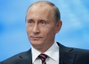 | «We are intending to work actively with authorities of the Arabic countries, in order to restore our economic positions… I see real premises for keeping by Russia its leading positions in Middle East arena, where we always had many friends» |  | 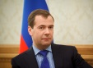 | «Our new strategy in Asia is a natural development of events and thoughtful response to the changing conditions of economic development»
Vladimir Putin, President of the Russian Federation |  |  | Dmitry Medvedev, Prime-Minister of the Russian Federation
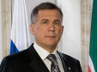 | «International economic summit of Russia and OIC countries aims to show openness and readiness of Russia to dialogue within the development of cooperation in the spheres of trade, foreign direct investment and discussion of Islamic financial system functioning issues» |  | 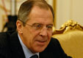 | «For the fifth time there was a success of the KazanSummit, caused considerable interest of the business community and investors from Islamic states. Intensified parliamentary component of our contacts with Islamic world»
Rustam Minnikhanov, President of Tatarstan |  |  | H.E. Sergey Lavrov, Foreign Minister of Russia
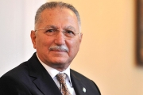 |  | «The summit testifies a determination to create a strong platform for economic cooperation between Russia and the Muslim world» | 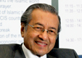 |  | «Tatarstan shows high investment opportunities due to political stability and respect for the equal rights of all ethnic groups»
Ekmeleddin Ihsanoğlu, Secretary-General of the OIC |  |  | H.E. Tun Dr Mahathir Mohamad, Ex-prime minister of Malaysia
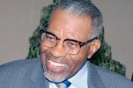 |  | «Thanks to the summit, new relations develop between businessmen of Tatarstan and our countries» | 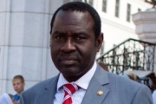 |  | «It is significant that the active participation of Parliamentarians of OIC countries contributes to the development of legal mechanisms for Islamic finance»
H.E. Dr. Ahmad Mohamed Ali, President of the Islamic Development Bank |  |  | Hameed A.Opeloyeru, OIC General Secretary's Assistant on Economic Matters
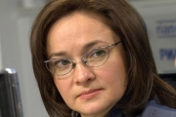 |  | «We have all opportunities to attract investment. Russia is comprised of 140 million people with high levels of consumption and education, and rich in natural resources» | 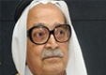 |  | «I am confident that the work of this summit aims to benefit all mankind and especially the Republic of Tatarstan. I wish success to this summit!»
Elvira Nabiullina, Head of Central Bank of Russia |  |  | H.E. Sheikh Saleh Kamel, Chairman, Islamic Chamber of Commerce and Industry
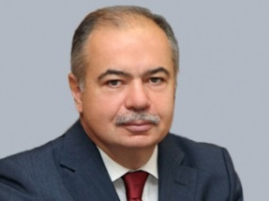 |  | «KazanSummit is distinguished from other international forums by its purposeful look for the models of productive cooperation between Russia and the Islamic world» | 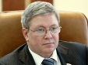 |  | «Islamic banks coming to Russia can benefit from our banking system. There are more than 20 million Muslims in Russia, and it is a significant factor in the development of the banking system in this direction»
Ilyas Umakhanov, Deputy Chairman of the Federation Council of the Russia |  |  | Alexander Torshin, Deputy Chairman of the Board of the Central Bank of Russia

