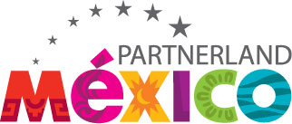

******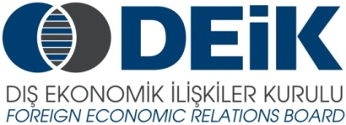

MEXICAN AUTOMOTIVE FORUM

Automechanika Istanbul 2013

April 11, 2013

*TUYAP Fair Center*

*İSTANBUL / Beylikdüzü, Turkey*

*MARMARA Salon, 1st floor of the MAIN FOYER of TUYAP Fair Center*

14:30 Registration

15:00 Welcoming Remarks

**Mr. Albert Saydam**, Chairman, DEIK/Turkish-Mexican Business Council

**H.E. Jaime Garcia Amaral**, Ambassador of the United Mexican States in Turkey

15:15 Presentations & Information Session

**Mr. Erwin Feldhaus**, Director Central & Eastern Europe, ProMexico:

***“Potentials of the Mexican Economy: The Automotive Industry”***

**Ms. Derya Akyuz,** Promexico Turkey Representative:

***“Investment Opportunities for Turkish companies in Mexico"***

**Ms. İnci Selin Aydın,** the Ministry of Economy of Turkey ***(tbc)***

Questions & Answers

16:00 Bilateral Meetings with Mexican Companies and Delegates