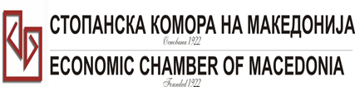
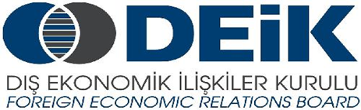

Бр: 14- 509/3 СКМ-ЗП-РУ-10/03

26.02.2015

Скопје

REGISTRATION FORM

МАКЕДОНСКО-ТУРСКA КОНВЕНЦИЈА
за заеднички настап на северно – африканскиот пазар,
23 март 2015
СТОПАНСКА КОМОРА НА МАКЕДОНИЈА

MACEDONIA – TURKEY – AFRICA
23.03.2015.

COMPANY INFORMATION
Company Name: | MZT PUMPI
Address: | Pero Nakov 126-Skopje
Year of Establishment | 1947
COMPANY REPRESENTATIVE INFORMATION
Name of the participant: | Zlatko Cvetkovski
Position in the company: | Head of Engineering Department
Languages spoken: | English

ACTIVITY OF THE COMPANY
Brief information about the company | Production, instalation and servicing of pumps and hydro mechanical equipment
FIELD OF ACTIVITY: | Process industry, water supply, irrigation, fire fighting,  Chemical nad petrochemical industry, cement industri...
Number of workers: | 110
Products/Servicess : | Pumps (centrifugal types, vertical turbine type, , hydro mechanical equipment
Expected cooperation from the Turkish partners at African market (please describe) | Trading companies id the field of pump business, founders
Total turnover in 2014(USD) | 5
Total export figure for 2014(USD) | 3.5
Exporting countries | Serbia, Bosnia & Herzegovina, Kosovo, Albania, Iraq, Bulgaria, Dubai...
Trademarks and certificates company have: | ISO 9001, ISO14001, OHSAS18001

Ве молиме за Вашиот интерес за учество на бизнис форумот, да го најавите најдоцна до 6.3.2015 година (петок).

