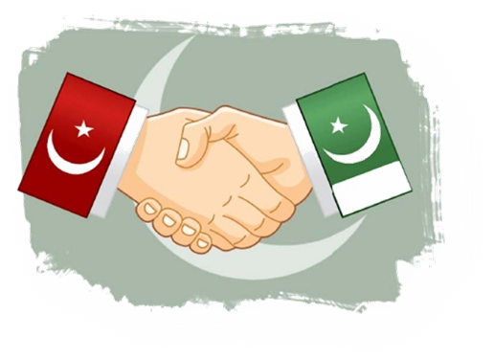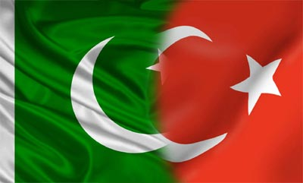

**INVITATION**

**TOURISM**

**TURKEY FAIR 2014**

IN **PAKISTAN**

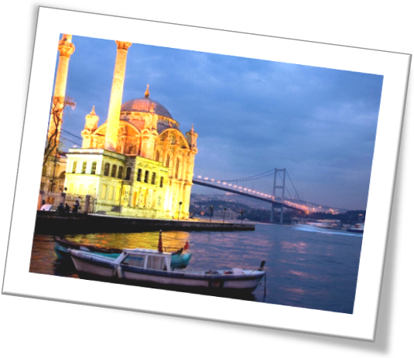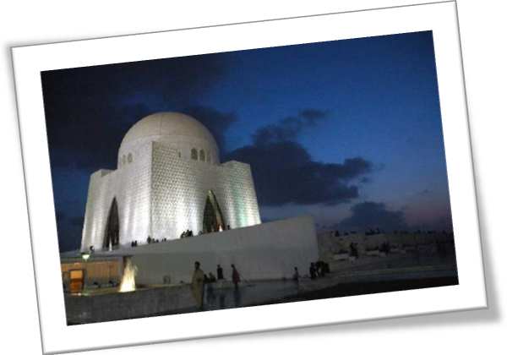

**INTRODUCTION**

We wish to introduce ourselves as event management company and are pleased to inform that we organized 6th Education Turkey Fair in Islamabad on November 19, 2013 which was attended by Turkish Ambassador.

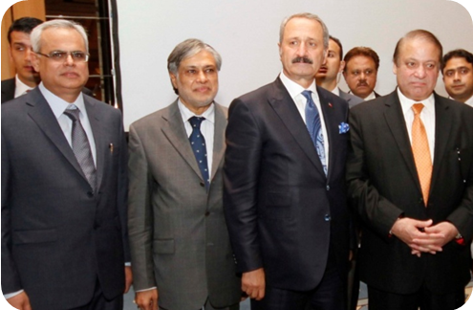

We plan to organize TOURISM TURKEY FAIR in Karachi in May 10 & 11, 2014. This will be the first TOURISM TURKEY FAIR being organized in Pakistan in Pakistan's commercial, industrial and financial hub Karachi, in its international standard Expo Centre. The aim of this Expo will be to inform Pakistani elite about tourism destinations in Turkey, so that more and more tourist can visit turkey in summer of 2014. The objective will be to promote tourism in Turkey. With increasing popularity of Turkish dramas in Pakistan it is right opportunity to attract Pakistani tourist to visit Turkey. As you know Pakistan has vast population of 200 million people and upper middle class and upper class people can go to Turkey instead of going to UK, USA, Malaysia, Thailand, Dubai etc for summer holidays.

M/s. Tri-Star Education is exclusive representative of almost all leading Turkish Universities in Pakistan and has successfully organized six EDUCATION TURKEY FAIRS in Pakistan in short span of three year. We are also exclusive agents for Pakistan for firm "Get Cured in Turkey" which represents leading Turkish Hospitals.

We attach herewith details of Fair and our company profile and look forward to receive positive response from you.

With best regards,

Tahir Ahmad

Chairman,

TRI-STAR EDUCATION

Education/Healthcare/Event Management

(Tri-Star Group)

404, Parsa Tower,

Sharah-e-Faisal,

Karachi-75350

Pakistan

Phone: 00- 9221-34150899

Mobile: 00-92300-8293988

www. educationturkey.com.pk

**DETAILS OF**

**TOURISM TURKEY FAIR 2014**

**IN PAKISTAN**

|  |  |
| --- | --- |
| **Date of Expo** | **May 10 & 11, 2014** |
| Venue | Expo Centre, Karachi, Pakistan |
| Duration of Fair | 2 days |
| Total Area | 2,230 square meter |
| Total workable area | 1,000 square meter |
| Total number of stalls | 50 |

**TRI-STAR GROUP OF COMPANIES**

**COMPANY PROFILE**

Tri-Star group comprises of following companies:

1. Indus Battery Industries (Pvt) Ltd ‘Deer’ Dry Battery Cell
2. Premier Battery Industries (Pvt) Ltd. ‘Crown’ Dry Battery Cell
3. First Tri-Star Modaraba Financial Institution dealing

in Shares / Trading activity.

1. Tri-Star Mutual Fund Ltd. Closed end Mutual Fund

in shares of listing companies.

1. Tri-Star Investments Ltd. Investment Advisory Services.
2. Tri-Star Power Ltd. 10 MW Captive thermal power

Plant supplying power to

Tri-Star Power Ltd.

1. Tri-Star Polyester Limited Polyester Yarn
2. Tri-Star Industries (Pvt) Ltd Natural Gas Generators from 30

Kva upto 130 kva.

“Image” Embroidered Fabric,

“Signal, Wisdom and Trista”

Tooth brushes, “Rex” Shoe

Polish and shoe care products.

1. Habib Jamal & Co Trading company dealing in

Import of stationery and

Other products

1. Tri-Star Education Education Consultants

Representative almost all

Major Turkish Universities in

Pakistan / Event Management

Company.

**INDUS BATTERY INDUSTRIES (PVT) LTD**

Indus Battery Industries (Pvt) ltd., is manufacturing “Deer” brand Dry Battery Cell for more than 35 years and is a leading brand of dry battery cell in rural Sindh and the Punjab, which is a major market for dry battery cells in Pakistan.

**PREMIER BATTERY INDUSTRIES (PVT) LTD.**

Premier Battery Industries (Pvt) Ltd is also manufacturing Dry Battery Cells under brand name “Crown” for more than 25 years, and has well established market in the Punjab.

**FIRST TRI-STAR MODARABA**

Tri-Star Modaraba is multi-purpose Modaraba engaged in buying/selling of securities/shares of listed public limited companies, leasing and trading activity.

**TRI-STAR MUTUAL FUND LTD.**

Tri-Star Mutual Fund Ltd is a closed end fund, dealing in share/securities of public listed companies.

**TRI-STAR INVESTMENTS LTD.**

Tri-Star Investments Ltd. is an Investment Advisor of Tri-Star Mutual Fund Ltd and also provides Investment Advisory Services.

**TRI-STAR POLYESTER LTD.**

Tri-Star Polyester Ltd. has production facility for manufacture of polyester yarn for local market and has state of art German plant & machinery.

**TRI-STAR POWER LTD.**

Tri-Star Power Ltd is captive power unit providing electricity to Tri-Star Polyester Ltd.

**TRI-STAR INDUSTRIES (PVT) LTD**

Tri-Star Industries (Pvt) Ltd, is dealing in following products:

**Tri-Star Gas Generators:**

We deal in Natural Gas Generators from 30 kva upto 130 kva. We are in generator business for more than 5 years and have sales and after sales service facility, with mobile trained technicians for prompt after sales service.

**“Image” brand Embroidered Fabric**

Image embroidered fabric is well established brand in Pakistan and Dubai. Image embroidered fabric is also being exported to India and is famous for its quality and unique designs.

**Trisa & Trista Tooth Brushes**

Company manufactures tooth brushes under brand name "Trisa" and "Trista". We used to manufacture "Pepsodent" tooth brush under contract for Unilever Pakistan Ltd.

**Rex Shoe Polish & other shoe care products**

Company manufacture Rex shoe polishes and other shoe care products. Rex is well known brand in the market, competing with well established international brands.

**HABIB JAMAL & CO:**

This is a trading company of our group and is primarily engaged in of stationery products and was sole distributor of Staedtler products in Pakistan for last 35 years and is sole distributor of LYRA stationery products from Germany. This company also imports other products for local market.

**TRI-STAR EDUCATION:**

Tri-Star Education is pioneer in introducing concept of single country education fairs in Pakistan and has been organizing Turkish Education Fairs in Pakistan for several years. 6th Education Turkey Fair was organized in November 2013. Tri-Star Education is also exclusive representative of almost all leading Turkish Universities in Pakistan.

Tri-Star Education is also exclusive representative of Turkish company “Get Cured in Turkey” which represents leading Turkish Hospitals including Anadolu Medical Centre etc.

**Management Profile:**

Mr. Tahir Ahmad is the Chairman of the Tri-Star Education and Director of Tri-Star Group. Mr. Tahir is Master of Business Administration and has 25 years of marketing experience in various fields.

Mr. Danish Ahmad is the Chief Executive Officer of Tri-Star Education and hold Bachelors of Business Administration degree from University of West Alabama (USA).

Ms. Sarah Ahmad is the Chief Operating Officer of Tri-Star Education and holds Master of Business Administration degree with majors in marketing and has several years experience.