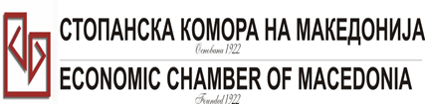
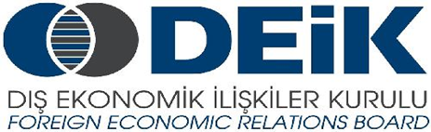

Бр: 14- 509/3 СКМ-ЗП-РУ-10/03

26.02.2015

Скопје

REGISTRATION FORM

МАКЕДОНСКО-ТУРСКA КОНВЕНЦИЈА
за заеднички настап на северно – африканскиот пазар,
23 март 2015
СТОПАНСКА КОМОРА НА МАКЕДОНИЈА

MACEDONIA – TURKEY – AFRICA
23.03.2015.

COMPANY INFORMATION
Company Name: | PIMACO dooel
Address: | Bul.Jane sandanski 61
Website:
Year of Establishment | 2000
COMPANY REPRESENTATIVE INFORMATION
Name of the participant: | Aleksandar Pisev
Position in the company: | Owner

ACTIVITY OF THE COMPANY
Brief information about the company | PIMAKO dooel Skopje is a manufacturing company and present on the Macedonian market for more than 15 years. We have also exported our products in Greece, Croatia, Serbia and Bosnia and Herzegovina. Our team consists of engineers and workers with 40 years of experience in this area. Together with our business partners we are able to produce various elements for water transport systems and other metal products. We are in close relationship and work together with MZT Learnica Skopje (largest Macedonian foundry) which product range offers different types of fittings material for water pipe systems mainly exported on the European markets. We also offer drainage equipment used for drainage systems in settlements.
FIELD OF ACTIVITY: | Production of the metal parts on the basis of the given sketches , engaged in production of equipment for water irrigation systems and water transport. Our core product is gate valve and other elements for water transport.
Number of workers: | Around 100
Products/Servicess : | Gate valves , many different parts for water irrigation systems and water transport and production and repair of many different metal parts
Expected cooperation from the Turkish partners at African market (please describe) | Cooperation with companies that build irrigation systems, drainage systems and drinking water systems in settlements in order to qualify our products
Total turnover in 2014(USD) | 8000000USD
Total export figure for 2014(USD) | 6500000USD
Exporting countries | Italia, Austria,Holland,Germany, Albania and all exYU countries
Trademarks and certificates company have: | ISO certificates

Ве молиме за Вашиот интерес за учество на бизнис форумот, да го најавите најдоцна до 6.3.2015 година (петок).

