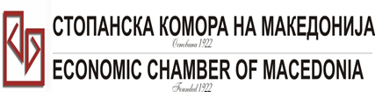
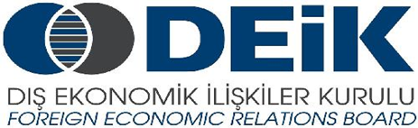

Бр: 14- 509/3 СКМ-ЗП-РУ-10/03

26.02.2015

Скопје

REGISTRATION FORM

МАКЕДОНСКО-ТУРСКA КОНВЕНЦИЈА
за заеднички настап на северно – африканскиот пазар,
23 март 2015
СТОПАНСКА КОМОРА НА МАКЕДОНИЈА

MACEDONIA – TURKEY – AFRICA
23.03.2015.

COMPANY INFORMATION
Company Name: | Comfy Angel DOO
Address: | Ul. Aleksandar Makedonski 1G/13 Prilep
Website: | www.somnia.com.mk
Year of Establishment | 2004
COMPANY REPRESENTATIVE INFORMATION
Name of the participant: | Irena Jakimovska
Position in the company: | Owner and Managing director

ACTIVITY OF THE COMPANY
Brief information about the company | Comfy Angel is company based in Macedonia operating throughout Europe and selling its products. Initially, the project was a CMT operation servicing our UK partner Comfy Quilts Ltd. Until recently we have been solely supporting the UK operation. However, we are now pro-actively growing our own sales across Europe. Mainly using synthetic materials, we produce on site pillows, quilts, throwovers, mattress covers, sleeping bags and all aspects of bedding. Besides the regular lines, we are also making a specific products such as waterproof, anti-allergenic and fire retardant items.We have a large capacity on site - monthly capacity up to 400,000 pillows, 120,000 duvets, 200,000 mattress protectors, 160,000 units of bedding, together with 140,000 pieces of in house designed packaging. And...we can extend this quickly by +30% within 4 weeks.Our site in Prilep is approx 22500m² and we employ near 1000 staff.
FIELD OF ACTIVITY: | Textile industry, production of home textiles  (pillows, quilts, throwovers, mattress covers, sleeping bags and all aspects of bedding)
Number of workers: | Near 1.000 employees
Products/Servicess : | pillows, quilts, throwovers, mattress covers, sleeping bags and all aspects of bedding
Expected cooperation from the Turkish partners at African market (please describe) | Potential suppliers of fabric, fiber, packaging etc. as well as potential customers
Total turnover in 2014(USD) | 11.500.000
Total export figure for 2014(USD) | 11.500.000
Exporting countries | Great Britain, France, Netherlands, Belgium, Italy, Austria, Germany, Romania, Bulgaria, Croatia, Greece, Turkey etc.
Trademarks and certificates company have: | OEKO Tex, BSCI etc.

Ве молиме за Вашиот интерес за учество на бизнис форумот, да го најавите најдоцна до 6.3.2015 година (петок).

