
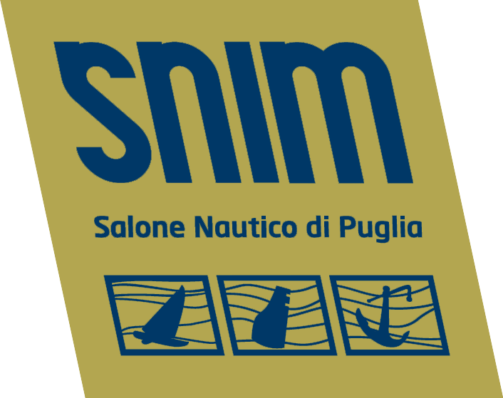
İTALYA'DA TÜRK TİCARET ODASI Consolato Generale Onorario di Turchia
Camera di Commercio Turca in Italia Brindisi

DEAR
COMPANIES INTERESTED

Oggetto: Apulia Boat Show and Business to Business Event
Honorary Consulate General of Turkey, Chamber of Commerce of Turkey in Italy and Apulia Boat Show, are pleased to invite firms of the Turkish countries to participate to the partnership event which will take place within the Apulia Boat Show, in Brindisi, from May 29 to June 2, 2013.

Business to business (B2B) event
The event aims to offer to firms of the boat fund and more generally, economy of the sea, the possibility to meet other firms operating in the same sector with the objective to present and discover new products and services, to explore new business opportunities, to find new potentials clients and suppliers, to find partners for joint venture or innovation projects. Due to internationalisation of the B2B event, the official language will be English.

Apulia Boat Show - Exhibitors
The organization will provide businesses with an exhibition stand for the duration of the Boat Show, from May 29 to June 2, 2013.
Companies will have the opportunity to deepen the contacts made during the Business to Business Event.

Who can participate
The event is addressed to firms operating in the nautical sector, both as products and services suppliers, in particular production sites, refitting, dealers, charter companies, suppliers of products and services with particular reference to marine accessories.

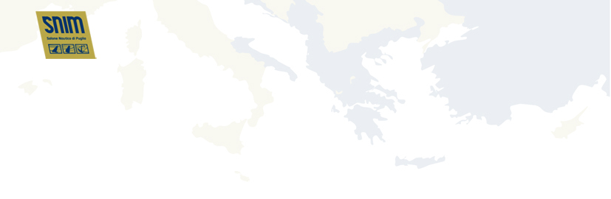

How does it work
The registered firms will be visible in this web site and it will be possible for the potential partners to visit their company profiles.
Therefore, each firm will have the possibility to select the more attractive firms for their business and request a meeting with them.
On the base of the requests, a personalized agenda will be elaborated for each firm. This agenda will contain the program of the meetings scheduled for the business to business event of the 30th May.
Each meeting will last for about 20 minutes.

Why to participate
The Boat Show of Apulia, better known as SNIM, now reference point for exhibitors and visitors, is at its 11th edition, scheduled in Brindisi from 29th May to 2nd June 2013, and confirms the strengths that have always characterized the event opening to the new market opportunities.
SNIM is situated in the beautiful area of Salento that best expresses the values of Apulia in terms of natural resources important for the pleasure boating, which is increasingly regarded as one of the most appealing international tourist destination for responsible tourism and with good spending capacity.
SNIM has been shown to be able to exploit the great opportunity of the geographical position as a gateway to the east overlooking the Balkans, and it has collected the support of all local institutions and particularly of Apulia Region that through the development of the Regional Boat District aims to foster and give a strong impetus to the growth of this sector.
Register online and submit your own cooperation profile on www.salonenauticopuglia.it by sending it by April 30, 2013
In your profile you can state what kind of technology/product/expertise you are offering, what kind of cooperation you are looking for and which ideas you would like to discuss with potential collaboration partners.
For further information write to info@salonenauticopuglia.it
Language: English
Costs Business to Business Event: Free of charge
Costs Exhibition Stand: € 500

