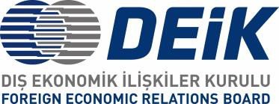 

|  |  |
| --- | --- |
| BANGLADESH – TÜRKİYE COOPERATION IN INFORMATION & COMMUNICTION TECHNOLOGIES  **Tuesday, 29.03.2022 | 14:00 – 17:30 Dhaka / 11:00 – 14:30 İstanbul**  WEBINAR - PROGRAM  **Online via Zoom** (Participation Link for the Webinar will be automatically sent following the Registration)  **Event Language:** English Moderator: tbc | |
| **11.00 – 11.15** | **OPENING REMARKS**   * Mr. Onur Özden, Chairperson DEİK Türkiye – Bangladesh Business Council * Dr. Bikarna Kumar Ghosh, Managing Director (Additional Secretary) Bangladesh Hi-Tech Park Authority (BHTPA) |
| **11.15 – 12.00** | **KEYNOTE ADDRESSES**   * Mr. N M Zeaul Alam, PAA, Sr. Secretary, ICT Division * H.E. Mustafa Osman Turan, Turkish Ambassador to Dhaka * H.E. Zunaid Ahmed Palak, Honorable State Minister, Bangladesh Ministry of ICT |
| **12.00 – 13.00** | **SPEECHES & PRESENTATIONS BY INDUSTRY REPRESENTATIVES**   * Mr. Hulusi Berik, President, Keiretsu Angel Investor Network & President, Crowd Funding Association * President, BASIS * Prof. Dr. Oğuz Bayat, Altınbaş, Dean of Altınbaş University & Founding Manager,   Altınbaş Teknokent   * President, BACCO * President, BCS * President, e-CAB |