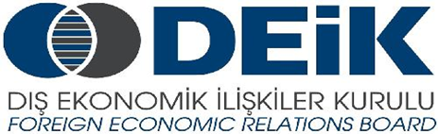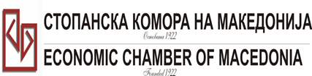

Бр: 14- 509/3 СКМ-ЗП-РУ-10/03

26.02.2015

Скопје

**REGISTRATION FORM**

**МАКЕДОНСКО-ТУРСКA КОНВЕНЦИЈА**

**за заеднички настап на северно – африканскиот пазар,**

**23 март 2015**

**СТОПАНСКА КОМОРА НА МАКЕДОНИЈА**

**MACEDONIA – TURKEY – AFRICA**

**23.03.2015.**

|  |  |
| --- | --- |
| **COMPANY INFORMATION** | |
| **Company Name:** | ADING A.D. |
| **Address:** | Novoselski pat (str. 1409) No.11 |
| **Website:** | www.ading.com.mk |
| **Year of Establishment** | 1969 |
| **COMPANY REPRESENTATIVE INFORMATION** |  |
| **Name of the participant:** | Jovanovski Goran |
| **Position in the company:** | COO |

|  |  |
| --- | --- |
| **ACTIVITY OF THE COMPANY** | |
| **Brief information about the company** | ADING a.d Skopje is business system for production, application, and sale of chemical products for the construction industry, and engineering works. The company was established in 1969 with its head office in Skopje. It is the largest firm in the Southeast Europe for construction chemical production.  The company employs 120 people of whom 40% have university education: civil engineers, architects, chemical engineers and technological engineers, that works in following departments: production, institute and development, technical application, engineering department.  Nowadays in Ading’s laboratories and production facilitates more than 100 products are created, with proved high and constant quality, which are used in civil engineering. Ading’s search and developing team follows and analyses new needs in civil engineering. The constant innovation and searching for new, improved product performances lead the company towards a new and higher technological level.  All of our products have EN certificates.  Since 26.May.1998 the company has been ISO 9002 certificated, since 1.March.2000 the company has been ISO 9001 certificated, and since 15 March 2006 the company has been certificated of environment management system, the ISO 14001/2004.  ADING products have been sold in many countries out  the world.  Headquarter is located in Skopje-Macedonia, and we have branch offices, factories and where houses in 13 countries. |
| **FIELD OF ACTIVITY:** | Production of chemical materials for construction industry and engineering works |
| **Number of workers:** | 120 |
| **Products/Servicess :** | * Concrete admihtures * Waterproofing * Fireprotection materials * Thermoisolation facades * Industrial floor * Signal paint for roads * Sport floors * Glue for cermaik, light briks, polysteren boards |
| **Expected cooperation from the Turkish partners at African market (please describe)** | Finding distributor for our products, or company welling to buy know-how for production of construction chemical materials. |
| **Total turnover in 2014(USD)** | **5.000.000** |
| **Total export figure for 2014(USD)** | **2.000.000** |
| **Exporting countries** | Serbia and Monte Negro, Bosnia and Herzegovina, Croatia, Slovenia, Hungary, Bulgaria, Greece, Albania, Russia, Ukraine, Kazakhstan, Kyrgyzstan, Azerbaijan, Iraq, Iran, United Arabian Emirates, Kuwait, Libya, Morocco and Cuba. |
| **Trademarks and certificates company have:** | (CE), (ISO 9001), (ISO 9002), (ISO 14001) |

Ве молиме за Вашиот интерес за учество на бизнис форумот, да го најавите **најдоцна до 6.3.2015 година (петок)*.***