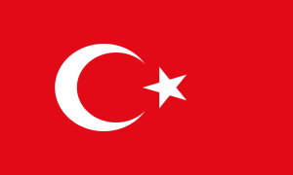


Türkiye-Tajikistan Business Roundtable Meeting

16 January 2023 / DEİK Office, Skyland İstanbul

10:30-11:00 Registration

11:00-11:10 Opening remarks

Moderator: Mr. Cihangir Fikri SAATÇİOĞLU, Chairman of the DEİK/Türkiye-Tajikistan Business Council

Mr. Ashrafjon GULOV, Ambassador of the Republic of Tajikistan to Türkiye (tbc)

The State Committee on Investment and State Property Management of the RT (SCISPM) (tbc)
11:10-11:30 Business and Investment Opportunities in Tajikistan
Moderator: Mr. Hakim İsmoilzoda, Economic and Commercial Counsellor, Embassy of the Republic of Tajikistan in the Republic of Türkiye
- Presentation of SUE “TAJINVEST’’
- Presentation of Chamber of Commerce and Industry of the Republic of Tajikistan

11:30-11:50 Introducing Tajik and Turkish Participants

Short introduction of the participant companies by their representatives and their brief assessments about the potential between Türkiye and Tajikistan (3 minutes for each company)

11:50-12:20 Q&A (B2G)

12:20- 12:30 MOU between Tajinvest and DEİK/Türkiye-Tajikistan Business Council (tbc)

Note: Turkish-Tajik consecutive translation will be provided.

