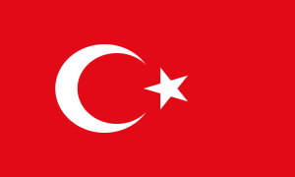
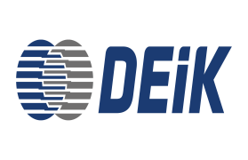
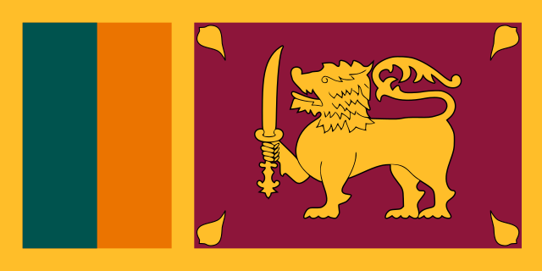
INTERCONNECTED BUSINESS SERIES
TURKEY – SRI LANKA
November 18th, Wednesday 2020, 10:30am (Istanbul Time) & 1:00pm (Colombo Time)
Zoom Video Conference
Moderator: Mr. Beşir UĞUR, Chairperson of the Turkey-Sri Lanka Business Council DEIK
10:30- 10:50 Opening Speeches

- Mr. Beşir UĞUR, Chairperson of the Turkey – Sri Lanka Business Council (DEIK)
- Mr. Prabhash SUBASINGHE, Chairman of Sri Lanka Export Development Board
- Mr. Nail OLPAK, President of Foreign Economic Relations Board (DEIK)
- H.E. Ms. Demet ŞEKERCİOĞLU, The Ambassador of The Republic of Turkey to Sri Lanka
- H.E. Mr. M. Rizvi HASSEN, The Ambassador of Sri Lanka to Turkey

10:50- 11:30 Session 1: Business and Investment Opportunities in Sri Lanka and Turkey

- Ms. Anoma PREMATHILAKE, Director (Market Development), Sri Lanka Export Development Board
- Mr. Prasanjith WIJAYATHILAKE, Executive Director, Board of Investment of Sri Lanka
- Mr. Dushan WICKRAMASURIYA, Director (Marketing), Sri Lanka Lanka Tourism Promotion Bureau
- Mr. Çağatay ÖZDEN, Head of Dept. of South Asian Countries, Turkish Ministry of Trade

11:30-12:00 Session 2: Sectoral Networking (simultaneously)

- Networking room 1: Food & Beverages

- Networking room 2: Rubber Products, Industrial Gloves, Yarn, Activated Carbon,
Ayurvedic Products & Coco-peat

- Networking room 3: Construction & Tourism

